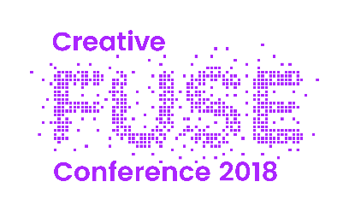

Workshop & Performance Funding
Small bursaries are available for participants in the conference who will be delivering workshops or performances. These can be used to cover the costs of any materials purchased especially for the workshop or performance in question, and/or your preparation time. To apply for a bursary please fill in the following details and return your completed form to faye.harland@ncl.ac.uk
***
Title of Workshop/Performance:

Name of lead contact:

Email address for lead contact:

Telephone number for lead contact:

Amount applying for:

Please provide an itemised breakdown of costs, providing details of what the materials will be used for where applicable.

